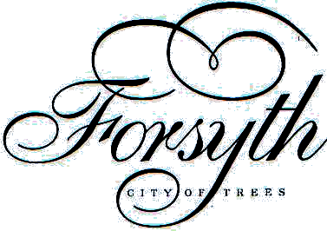
CITY OF FORSYTH
CITY COUNCIL MEETING AGENDA
CITY HALL COUNCIL CHAMBERS
247 NORTH 9TH AVENUE

MONDAY May 12, 2025

7:00 P.M. COUNCIL PROCEEDINGS

I. PLEDGE OF ALLEGIANCE

II. PUBLIC COMMENT – The public may address the Council on any public matter that is not on the agenda. There will be no discussion of personnel. The Council will take no formal action at this point in the agenda. Public comment will be incorporated into the official minutes of the meeting. Comments should be limited to 3-5 minutes per issue.

III. PUBLIC HEARING-None

IV. REVIEW - REVISE AGENDA

V. CONSENT AGENDA – INFO/ACTION
A. Minutes
1. Regular Meeting Minutes of April 14, 2025

B. Claims and Checks:
1. Claims: 24191-24251
Total: $60,439.45
2. Checks: 22829-22890
Total: $106,824.54
C. 1. Cash and Finance Reconciliation
2. Payroll Reports
3. First State Bank Pledged Accounts
4. MDU Cost Comparison – Pool
5. CEDS report 2024
6. Tree City USA award letter

VI. CITIZENS – All ITEMS LISTED ARE INFO/ACTION ITEMS

A. Unfinished Business -None

B. New Business – None

VII. DEPARTMENT HEAD REPORTS
A. City Clerk/Treasurer
B. Public Works
C. Water/Wastewater
D. Pool
1. Request to Purchase Pool Cover
E. Rosebud County Sheriff’s Office
F. Code Enforcement

VIII. OLD BUSINESS – ALL ITEMS LISTED ARE INFO/ACTION ITEMS

A. Levee Update
B. Water Project Update
1. Water Tank Painting
C. TA Grant
D. Front Street Project/Trees
E. Surplus Property Sale-1976 Ford Dump Truck with 1991 Airflow Sander-Resolution No. 2025-R02

IX. NEW BUSINESS – ALL ITEMS LISTED ARE INFO/ACTION ITEMS

- Taylor Hallman-Code Enforcement Contract Renewal
- Proposal for Non-profit city grant

X. REPORTS-INFORMATIONAL

A. City Judge
1. Report
B. City Council
1. Report
C. Mayor
1. Report
D. City Attorney
1. Report

XI. COMMITTEES/COMMISSIONS REPORTS

A. Services and Policy
1. Parks and Public Works-Council Members Purkett and Bell
2. Water & Sewer-Council Members Bell and Roberts
3. Pool and Recreation-Council Members Beyl and Roberts
4. Police Commission-Council Members Beyl and Roberts
5. Policy and Code- Council Members Chris Purkett and Ethan Bell
XII. NEXT MEETING DATE June 9, 2025

XIII. AGENDA ITEMS FOR THE NEXT MEETING

